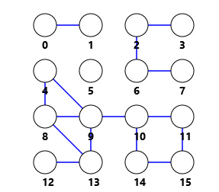

|  |  |
| --- | --- |
| adj[] |  |
| 0 | 1 |
| 1 | 0 |
| 2 | 6 3 |
| 3 | 2 |
| 4 | 9 8 |
| 5 |  |
| 6 | 7 2 |
| 7 | 6 |
| 8 | 13 9 4 |
| 9 | 13 10 8 4 |
| 10 | 14 11 9 |
| 11 | 15 10 |
| 12 | 13 |
| 13 | 12 9 8 |
| 14 | 15 10 |
| 15 | 14 11 |

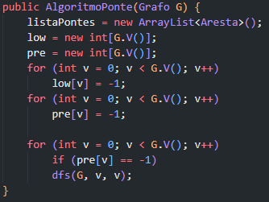

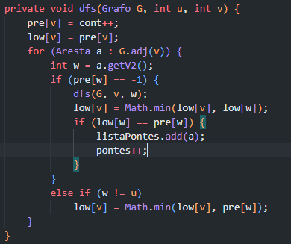

|  |  |  |
| --- | --- | --- |
| V | Pre[] | Low[] |
| 0 | 0 | 0 |
| 1 | 1 | 1 |
| 2 | 2 | 2 |
| 3 | 5 | 5 |
| 4 | 6 | 6 |
| 5 | 15 | 15 |
| 6 | 3 | 3 |
| 7 | 4 | 4 |
| 8 | 10 | 6 |
| 9 | 7 | 6 |
| 10 | 11 | 11 |
| 11 | 14 | 11 |
| 12 | 9 | 9 |
| 13 | 8 | 6 |
| 14 | 12 | 11 |
| 15 | 13 | 11 |

|  |
| --- |
| Fila (Início) |
| ~~dfs(G, 5, 5)~~ |
| ~~dfs(G, 15, 11)~~ |
| ~~dfs(G, 14, 15)~~ |
| ~~dfs(G, 10, 14)~~ |
| ~~dfs(G, 9, 10)~~ |
| ~~dfs(G, 13, 8)~~ |
| ~~dfs(G, 13, 12)~~ |
| ~~dfs(G, 9, 13)~~ |
| ~~dfs(G, 4, 9)~~ |
| ~~dfs(G, 4, 4)~~ |
| ~~dfs(G, 2, 3)~~ |
| ~~dfs(G, 6, 7)~~ |
| ~~dfs(G, 2, 6)~~ |
| ~~dfs(G, 2, 2)~~ |
| ~~dfs(G, 0, 1)~~ |
| ~~dfs(G, 0, 0)~~ |

|  |
| --- |
| ListaPontes |
| 0 | 1 |
| 6 | 7 |
| 2 | 6 |
| 2 | 3 |
| 13 | 12 |
| 9 | 10 |